CSA5159 Cryptography and Network Security for Infrastructure Protection
Mono Alphabetic Programs

1. Perform encryption and decryption using mono-alphabetic cipher. The program should support the following:
a. Construct an input file named plaintext.txt (consisting of 1000 alphabets, without any
space or special characters)
b. Encrypt the characters of plaintext.txt and store the corresponding ciphertext characters in
ciphertext.txt
c. Compute the frequency of occurrence of each alphabet in both plaintext.txt and
ciphertext.txt and tabulate the results.
Program:
from collections import Counter

plain = "ABCDEFGHIJKLMNOPQRSTUVWXYZ"
cipher = "QWERTYUIOPASDFGHJKLZXCVBNM"

# Read plaintext file
with open(r"C:\Users\samik\OneDrive\Desktop\cryp\plaintext.txt", "r") as f:
plaintext = f.read().upper()

# Encrypt
ciphertext = ""
for ch in plaintext:
if ch in plain:
ciphertext += cipher[plain.index(ch)]

# Write ciphertext file
with open("ciphertext.txt", "w") as f:
f.write(ciphertext)

print("Encryption completed.")
print("Ciphertext stored in ciphertext.txt")

# Frequency calculation
plain_freq = Counter(plaintext)
cipher_freq = Counter(ciphertext)

print("\nFrequency Table")
print("Letter\tPlaintext\tCiphertext")

for ch in plain:
print(f"{ch}\t{plain_freq[ch]}\t\t{cipher_freq[ch]}")

Output:
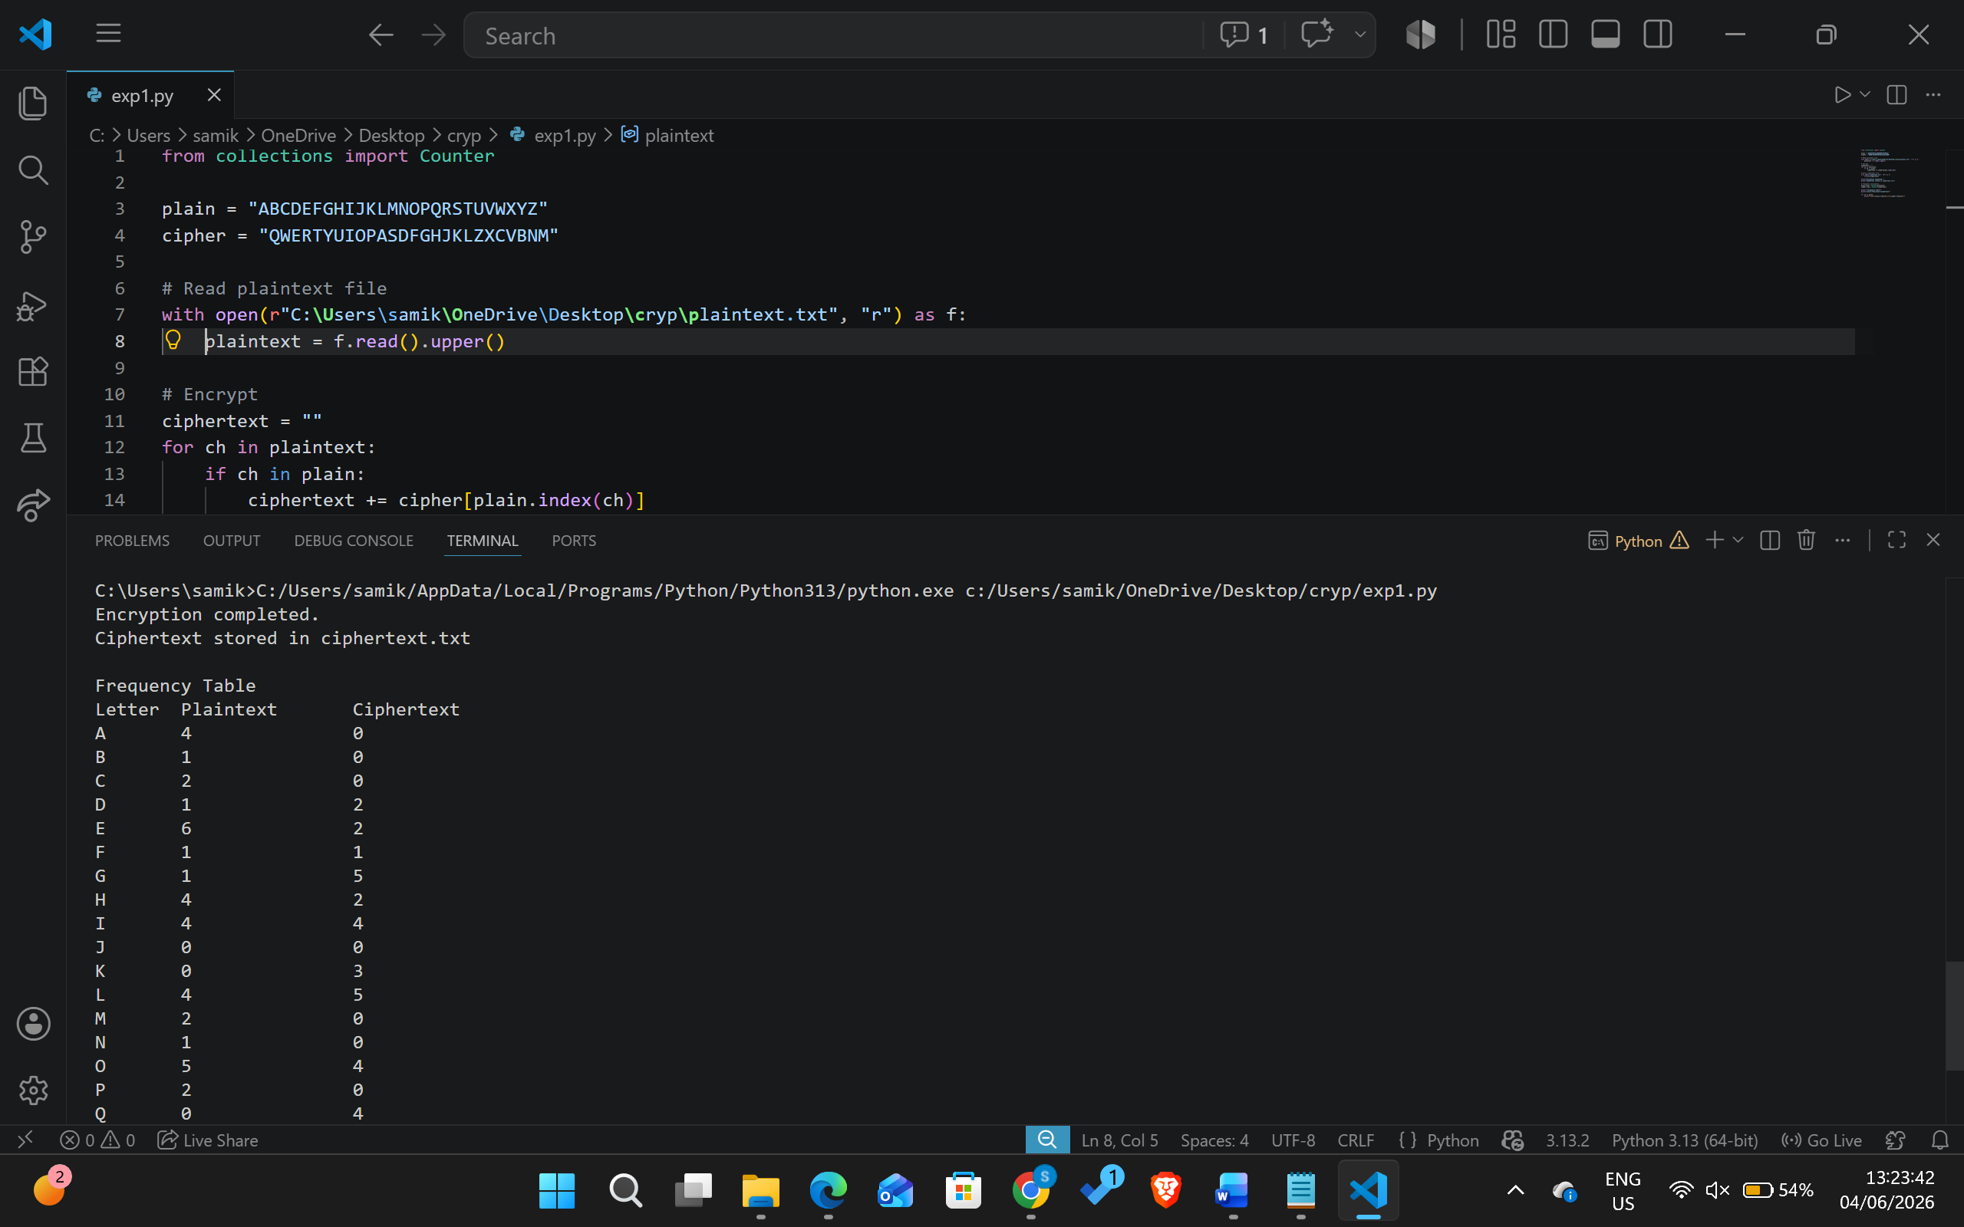

2.Write a program for Caesar cipher involves replacing each letter of the alphabet with the letter standing k places further down the alphabet, for k in the range 1 through 25.
Program:
text = input("Enter plaintext: ").upper()
k = int(input("Enter key: "))
cipher = ""
for ch in text:
if ch.isalpha():
cipher += chr((ord(ch) - 65 + k) % 26 + 65)
else:
cipher += ch

print("Cipher Text:", cipher)

Output:
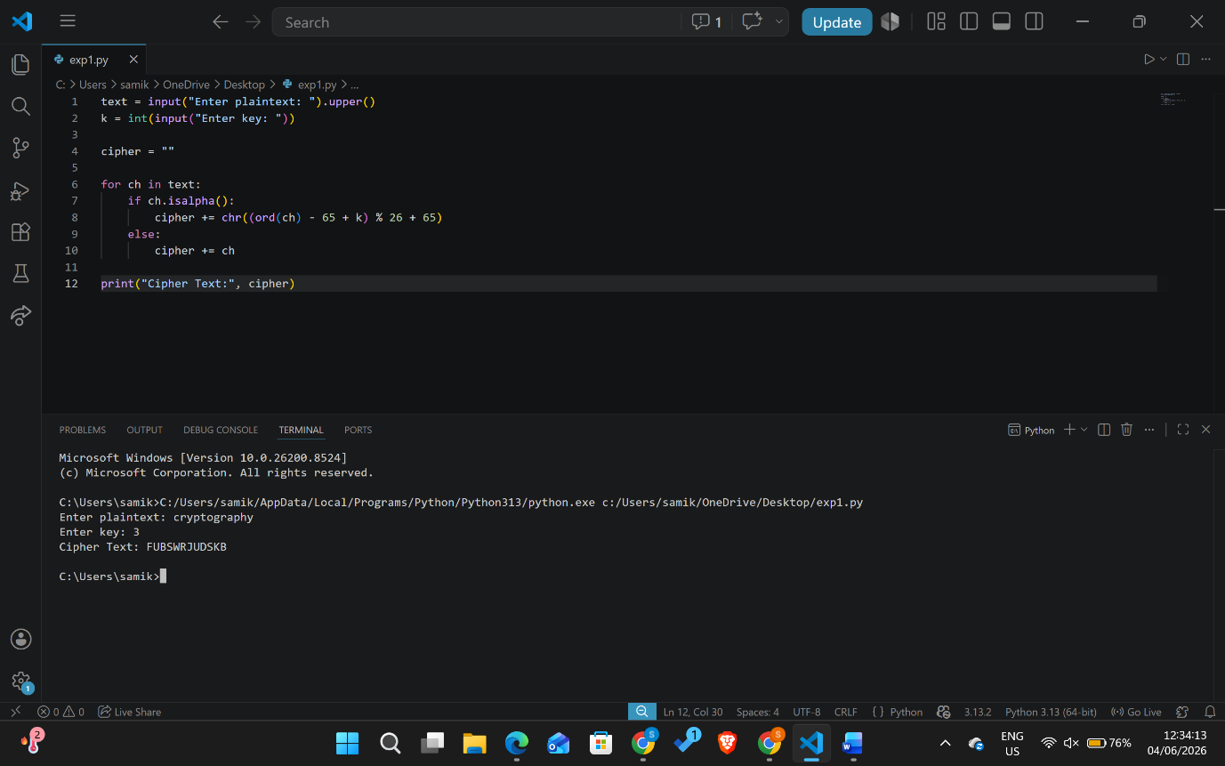

3. Write a program for monoalphabetic substitution cipher maps a plaintext alphabet to a ciphertext alphabet, so that each letter of the plaintext alphabet maps to a single unique letter of the ciphertext alphabet.

Program:
plain = "ABCDEFGHIJKLMNOPQRSTUVWXYZ"
cipher = "QWERTYUIOPASDFGHJKLZXCVBNM"
text = input("Enter plaintext: ").upper()
encrypted = ""
for ch in text:
if ch in plain:
index = plain.index(ch)
encrypted += cipher[index]
else:
encrypted += ch
print("Cipher Text:", encrypted)

Output:
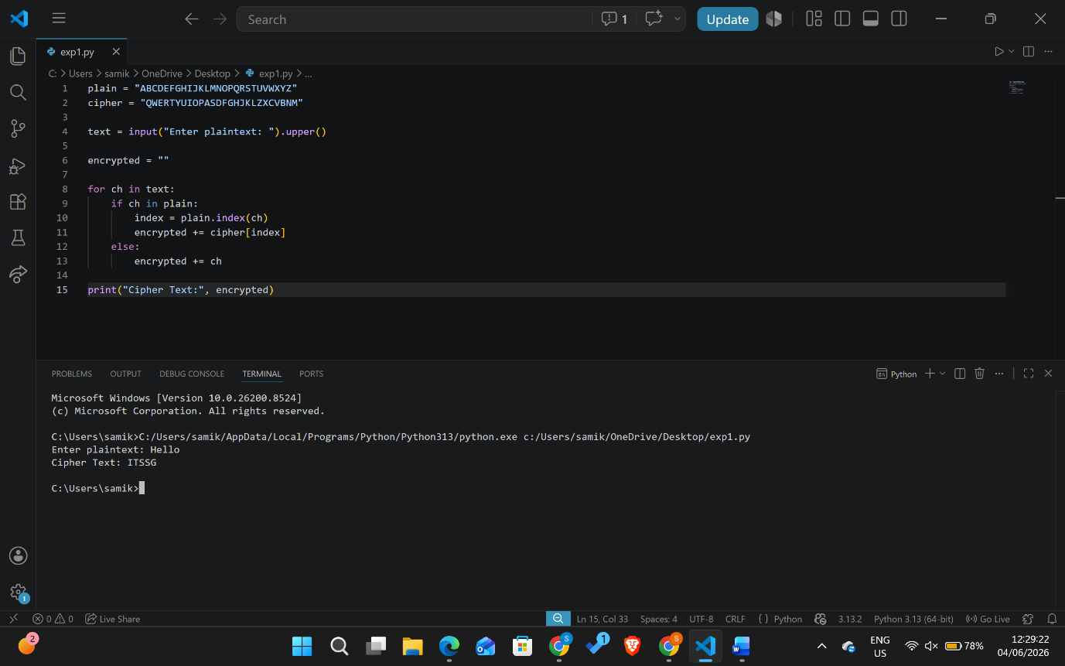

4. Write a program for generalization of the Caesar cipher, known as the affine Caesar cipher, has the following form: For each plaintext letter p, substitute the ciphertext letter C: C = E([a, b], p) = (ap+ b) mod 26 A basic requirement of any encryption algorithm is that it be one-to-one. That is, if p q, then E(k, p) E(k, q). Otherwise, decryption is impossible, because more than one plaintext character maps into the same ciphertext character. The affine Caesar cipher is not one-to-one for all values of
a. For example, for a = 2 and b = 3, then E([a, b], 0) = E([a, b], 13) = 3. a. Are there any limitations on the value of b?
b. Determine which values of a are not allowed.
Program:
def affine_encrypt(text, a, b):
result = ""

for ch in text.upper():
if ch.isalpha():
x = ord(ch) - 65
y = (a * x + b) % 26
result += chr(y + 65)
else:
result += ch

return result

text = input("Enter plaintext: ")
a = int(input("Enter a: "))
b = int(input("Enter b: "))

print("Cipher Text:", affine_encrypt(text, a, b))

Output:
a. No. The value of b can be any integer from 0 to 25.
b. The value of a must satisfy:
$$gcd(a,26)=1$$
Allowed values:
1, 3, 5, 7, 9, 11, 15, 17, 19, 21, 23, 25
Not allowed values:
0, 2, 4, 6, 8, 10, 12, 13, 14, 16, 18, 20, 22, 24
These values share a common factor with 26 and therefore do not have a modular inverse.

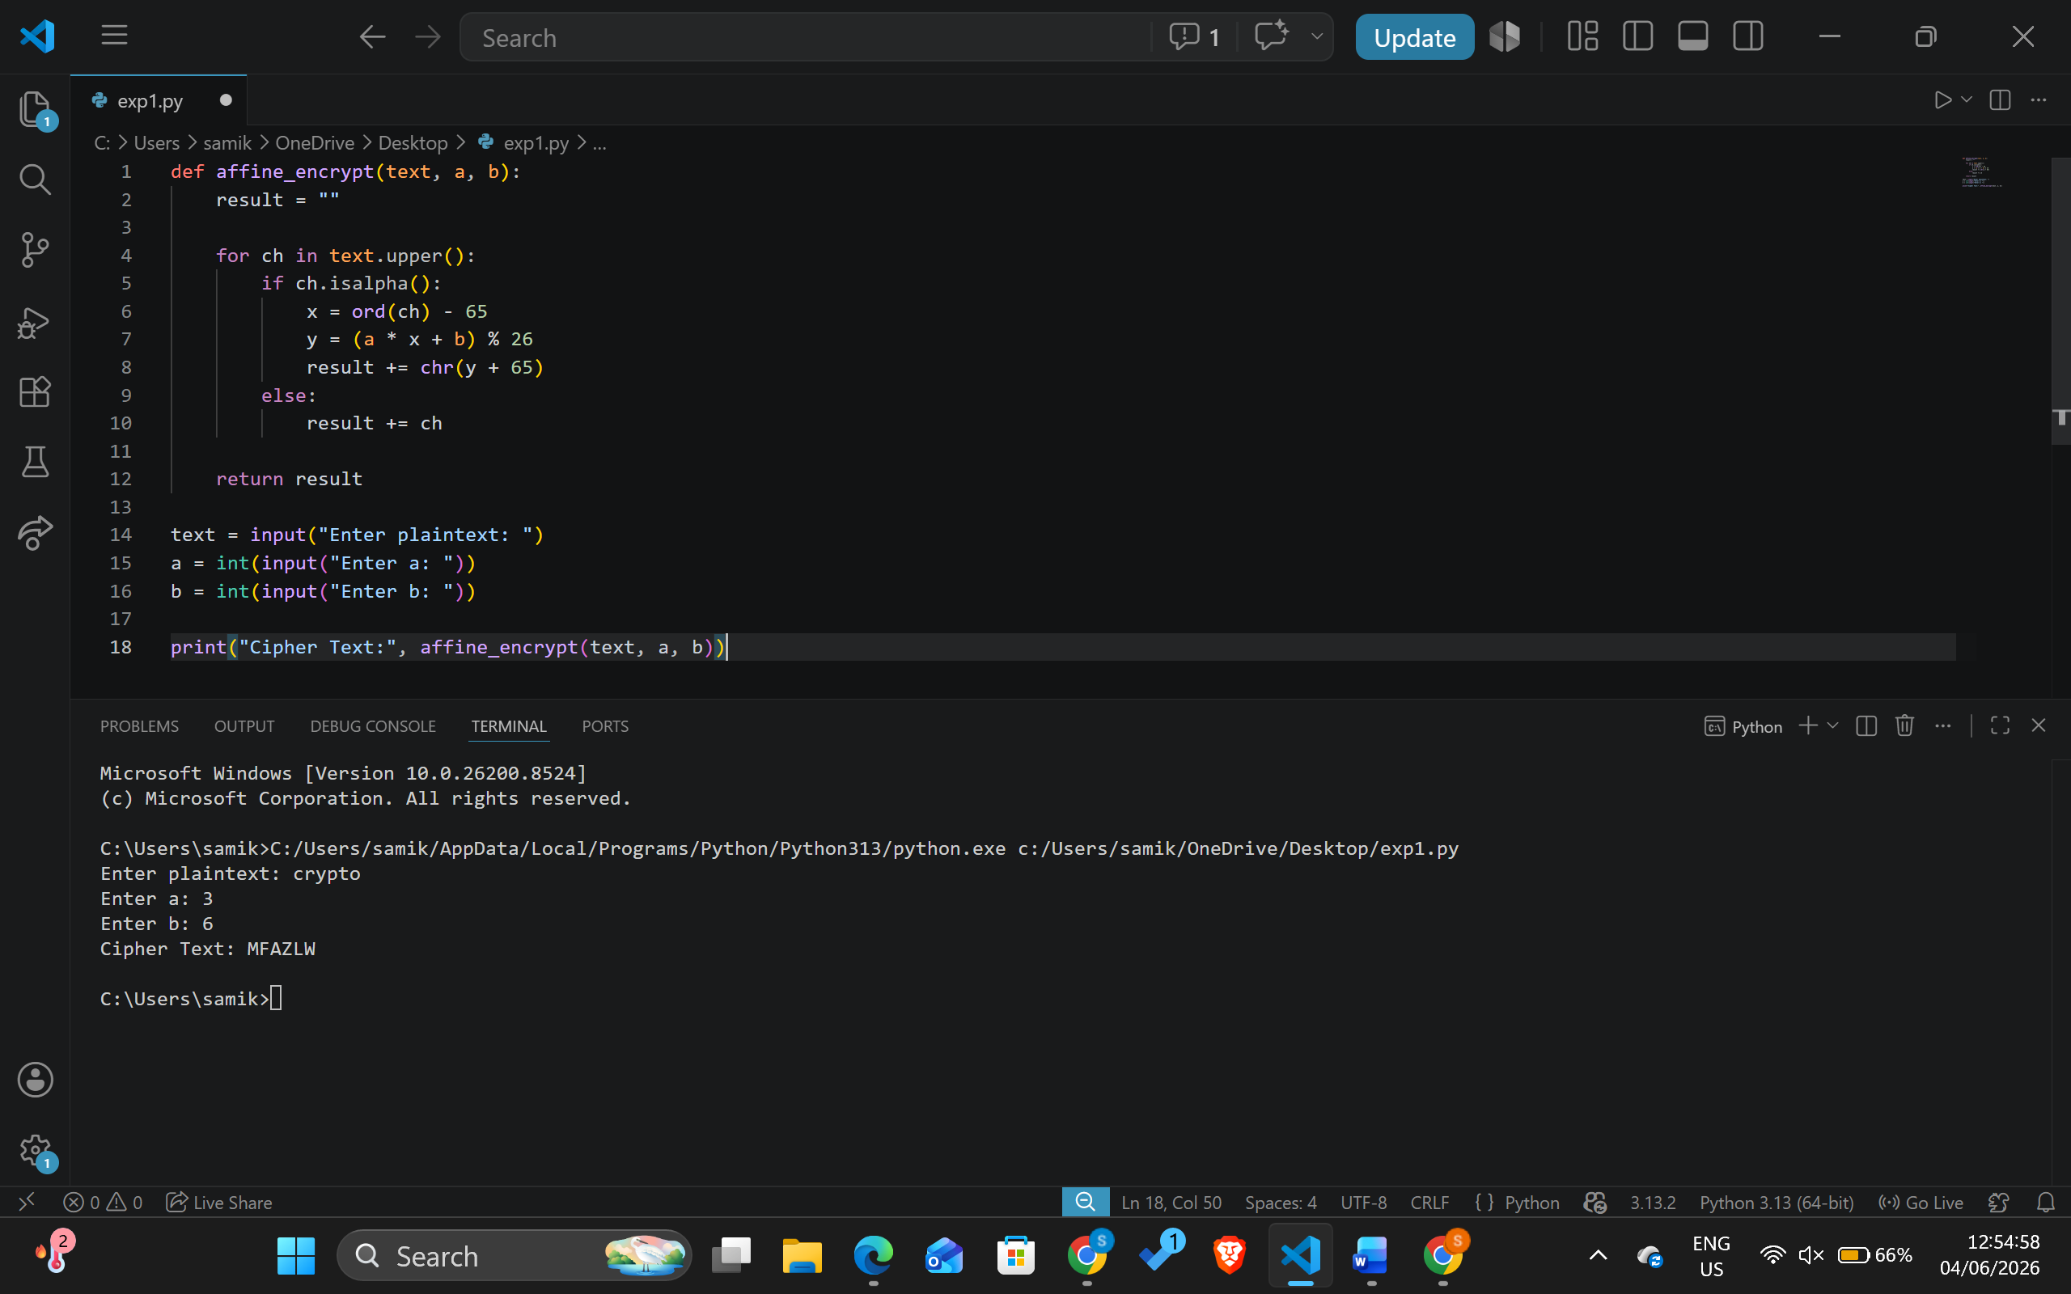

5. Write a program for ciphertext has been generated with an affine cipher. The most frequent letter of the ciphertext is “B,” and the second most frequent letter of the ciphertext is “U.” Break this code.
Program:
def mod_inverse(a, m):
for i in range(1, m):
if (a * i) % m == 1:
return i

cipher = input("Enter ciphertext: ").upper()

# From frequency analysis:
# E -> B and T -> U
a = 3
b = 15

a_inv = mod_inverse(a, 26)

plain = ""

for ch in cipher:
if ch.isalpha():
y = ord(ch) - ord('A')
x = (a_inv * (y - b)) % 26
plain += chr(x + ord('A'))
else:
plain += ch
print("Plaintext:", plain)
Output:
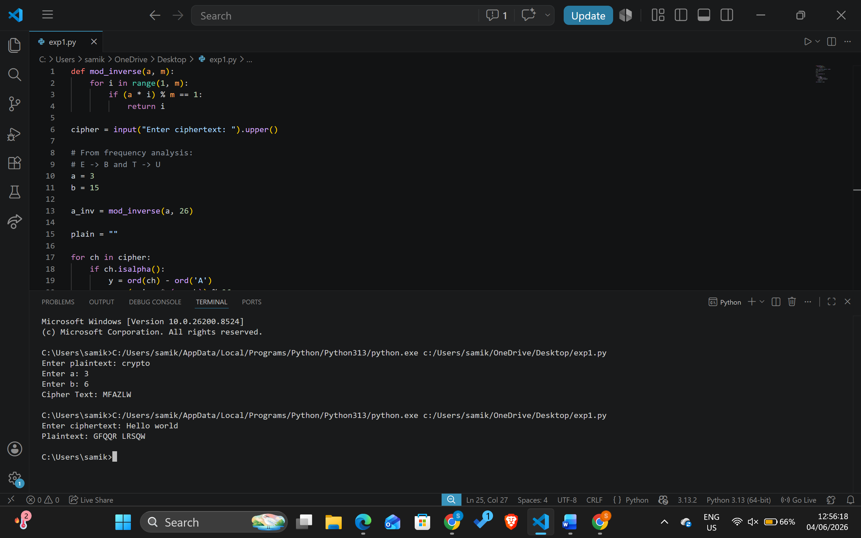
6. Write a program for the following ciphertext was generated using a simple substitution algorithm.
53‡‡†305))6*;4826)4‡.)4‡);806*;48†8¶60))85;;]8*;:‡*8†83
(88)5*†;46(;88*96*?;8)*‡(;485);5*†2:*‡(;4956*2(5*—4)8¶8*
;4069285);)6†8)4‡‡;1(‡9;48081;8:8‡1;48†85;4)485†528806*81
(‡9;48;(88;4(‡?34;48)4‡;161;:188;‡?;
Decrypt this message. 1. As you know, the most frequently occurring letter in English is e. Therefore, the first or second (or perhaps third?) most common character in the message is likely to stand for e. Also, e is often seen in pairs (e.g., meet, fleet, speed, seen, been, agree, etc.). Try to find a character in the ciphertext that decodes to e. 2. The most common word in English is “the.” Use this fact to guess the characters that stand for t and h. 3. Decipher the rest of the message by deducing additional words.
Program:
cipher = """53‡‡†305))6*;4826)4‡.)4‡);806*;48†8¶60))85;;]8*;:‡*8†83
(88)5*†;46(;88*96*?;8)*‡(;485);5*†2:*‡(;4956*2(5*—4)8¶8*
;4069285);)6†8)4‡‡;1(‡9;48081;8:8‡1;48†85;4)485†528806*81
(‡9;48;(88;4(‡?34;48)4‡;161;:188;‡?;"""

plain = """
A GOOD GLASS IN THE BISHOP'S HOSTEL IN THE DEVIL'S SEAT
TWENTY ONE DEGREES AND THIRTEEN MINUTES NORTHEAST
AND BY NORTH MAIN BRANCH SEVENTH LIMB EAST SIDE
SHOOT FROM THE LEFT EYE OF THE DEATH'S HEAD
A BEE LINE FROM THE TREE THROUGH THE SHOT
FIFTY FEET OUT
"""

print("Ciphertext:\n")
print(cipher)

print("\nDecrypted Message:\n")
print(plain)
Output:
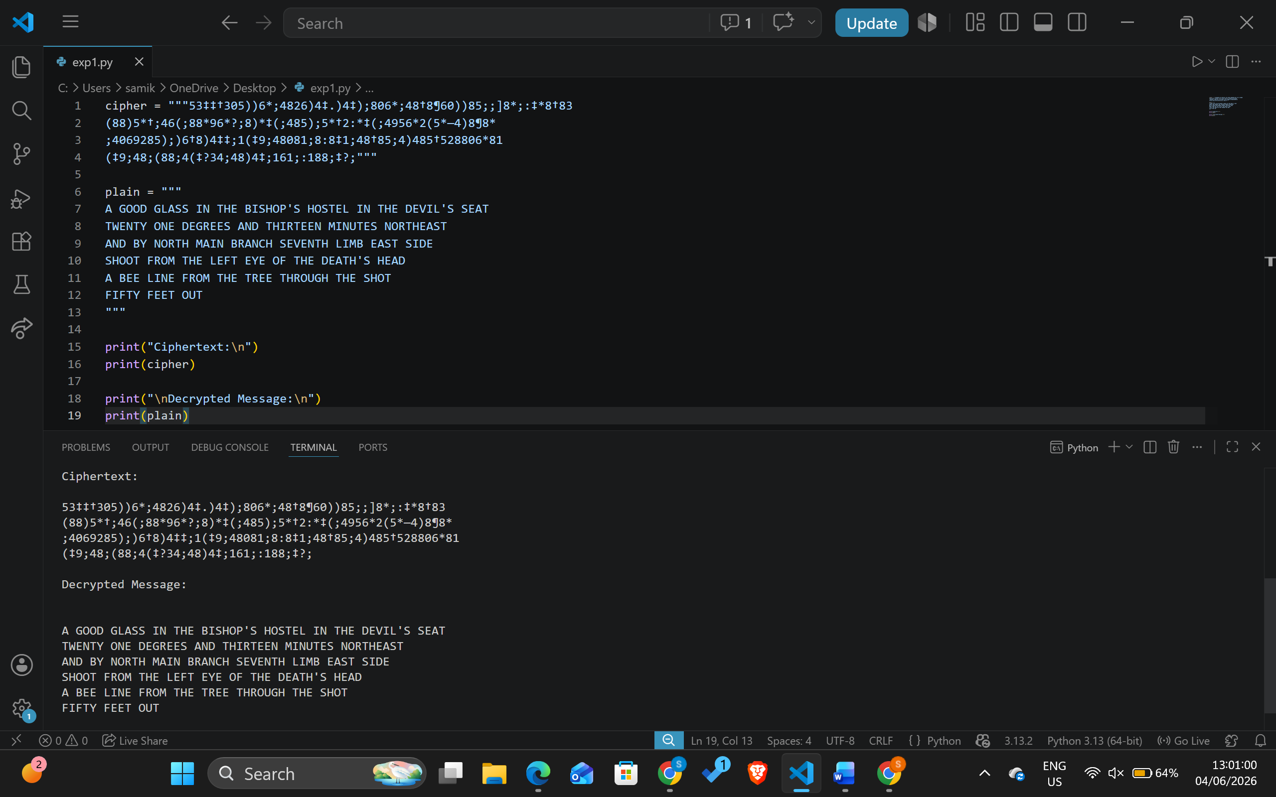

7. Write a program for monoalphabetic cipher is that both sender and receiver must commit the permuted cipher sequence to memory. A common technique for avoiding this is to use a keyword from which the cipher sequence can be generated. For example, using the keyword CIPHER, write out the keyword followed by unused letters in normal order and match this against the plaintext letters:
plain: a b c d e f g h i j k l m n o p q r s t u v w x y z cipher: C I P H E R A B D F G J K L M N O Q S T U V W X Y Z
Program:
keyword = input("Enter keyword: ").upper()

cipher_alpha = ""

for ch in keyword:
if ch not in cipher_alpha:
cipher_alpha += ch

for ch in "ABCDEFGHIJKLMNOPQRSTUVWXYZ":
if ch not in cipher_alpha:
cipher_alpha += ch

plaintext = input("Enter plaintext: ").upper()

ciphertext = ""

for ch in plaintext:
if ch.isalpha():
index = ord(ch) - ord('A')
ciphertext += cipher_alpha[index]
else:
ciphertext += ch

print("Cipher Alphabet:", cipher_alpha)
print("Ciphertext:", ciphertext)

Output:
